Parallelogram-Based Prismoid

Definition
# Source: AI Source: Provided by: [Data Path: Persons Table -> ID Column: 1, Name_En Column: Motasem Essam] -> From: [ChatGPT] on [7/25/2026]
A Parallelogram-Based Prismoid is a three-dimensional polyhedron belonging to the Quadrilateral Prismoid family, characterized by two parallelogram bases lying in parallel planes and connected by four quadrilateral lateral faces.
The two bases have four sides each, with opposite sides parallel and equal, but they do not necessarily have the same size, shape, or orientation. Their interior angles are not necessarily right angles. The lateral faces are trapezoids or parallelograms.
It has 6 faces, 12 edges, and 8 vertices.

Geometric Structure
# Source: AI Source: Provided by: [Data Path: Persons Table -> ID Column: 1, Name_En Column: Motasem Essam] -> From: [ChatGPT] on [7/25/2026]
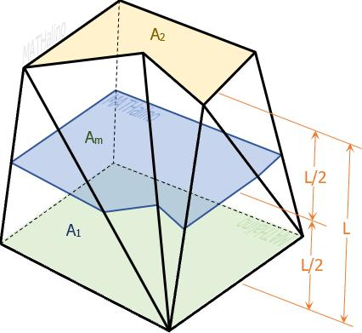
The solid consists of the following elements:
- Lower Parallelogram Base: A four-sided polygon with two pairs of parallel opposite sides, forming the bottom of the solid.
- Upper Parallelogram Base: A parallelogram parallel to the lower base.
- Lateral Faces: Four quadrilateral faces connecting corresponding edges of the two bases.
- Lateral Edges: Four edges connecting corresponding vertices of the bases.
- Altitude (Height): The perpendicular distance between the two base planes.
- Midsection: A quadrilateral cross-section parallel to both bases, halfway between them.

Face Composition
# Source: AI Source: Provided by: [Data Path: Persons Table -> ID Column: 1, Name_En Column: Motasem Essam] -> From: [ChatGPT] on [7/25/2026]
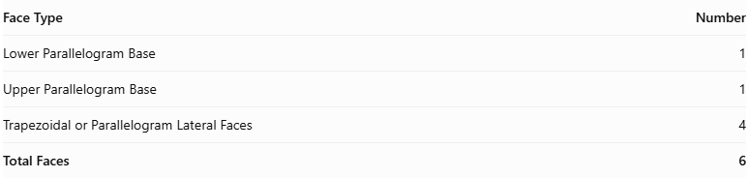
Face Type | Number
Lower Parallelogram Base | 1
Upper Parallelogram Base | 1
Trapezoidal or Parallelogram Lateral Faces | 4
Total Faces | 6
The four lateral faces may be trapezoids or parallelograms, depending on the relative positions and orientations of the bases.

Mathematical Properties
# Source: AI Source: Provided by: [Data Path: Persons Table -> ID Column: 1, Name_En Column: Motasem Essam] -> From: [ChatGPT] on [7/25/2026]
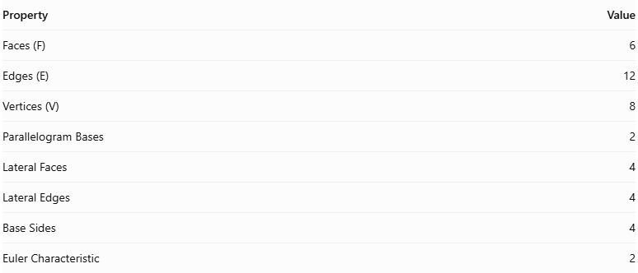
Property | Value
Faces (F) | 6
Edges (E) | 12
Vertices (V) | 8
Parallelogram Bases | 2
Lateral Faces | 4
Lateral Edges | 4
Base Sides | 4
Euler Characteristic | 2
Euler Characteristic:
$$V-E+F=2$$
Volume Formula:
$$V=\frac{h}{6}(A_{1}+4A_{m}+A_{2})$$
Where:
- $V$ = Volume.
- $h$ = Perpendicular height.
- $A_{1}$ = Area of the lower parallelogram base.
- $A_{2}$ = Area of the upper parallelogram base.
- $A_{m}$ = Area of the quadrilateral midsection.
The area of a parallelogram base can be calculated using:
$$A=bh$$
Where:
- $b$ = Base length.
- $h$ = Perpendicular height of the parallelogram.

Geometric Characteristics
# Source: AI Source: Provided by: [Data Path: Persons Table -> ID Column: 1, Name_En Column: Motasem Essam] -> From: [ChatGPT] on [7/25/2026]
- Parallelogram Bases: Both parallel bases have two pairs of parallel and equal opposite sides.
- Quadrilateral Lateral Faces: The solid has four trapezoidal or parallelogram lateral faces.
- Variable Base Geometry: The upper and lower parallelograms may differ in dimensions and angles.
- Inclined Lateral Edges: The connecting edges may be inclined relative to the base planes.
- Convex Structure: In its conventional form, the solid has a convex closed surface.
- Variable Configurations: Its appearance depends on the dimensions, angles, and relative positions of its two parallelogram bases.

Types of Parallelogram-Based Prismoids
# Source: AI Source: Provided by: [Data Path: Persons Table -> ID Column: 1, Name_En Column: Motasem Essam] -> From: [ChatGPT] on [7/25/2026]
Parallelogram-based prismoids can be further classified according to their configurations:
- Right Parallelogram-Based Prismoid
- Oblique Parallelogram-Based Prismoid
- Regular Parallelogram-Based Prismoid
- Irregular Parallelogram-Based Prismoid
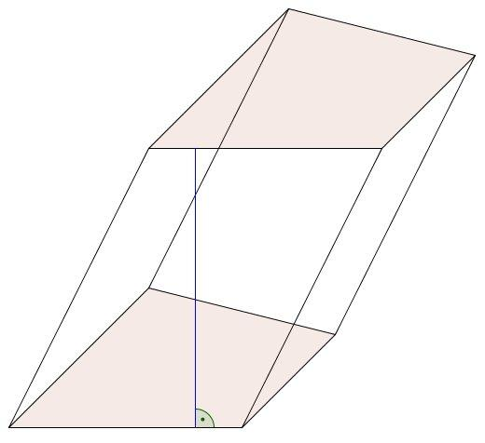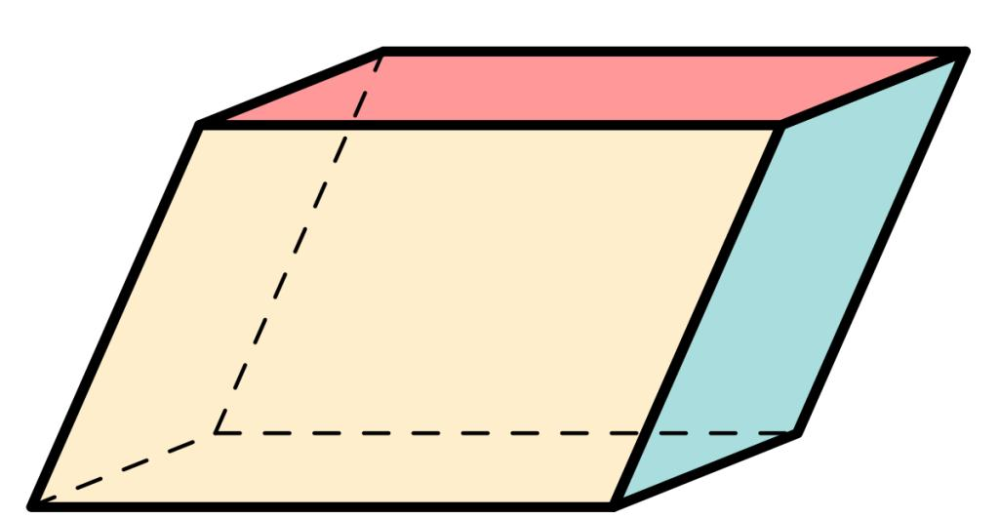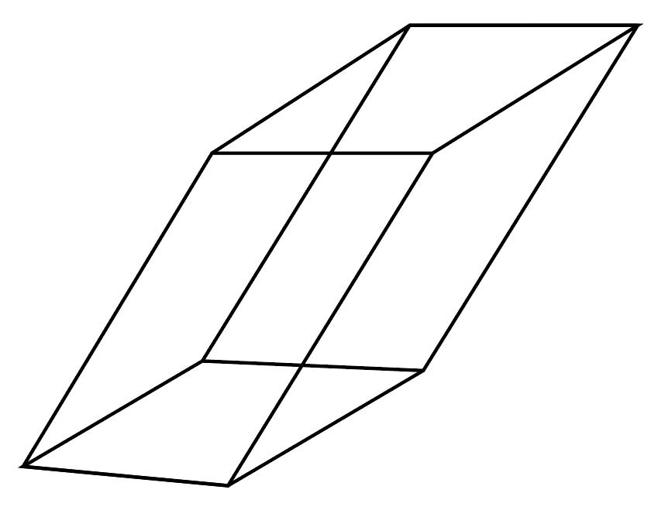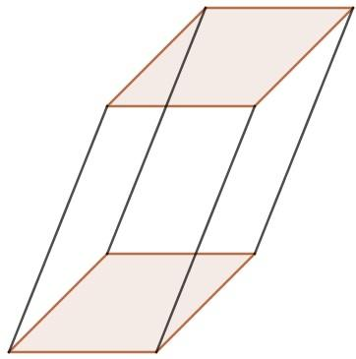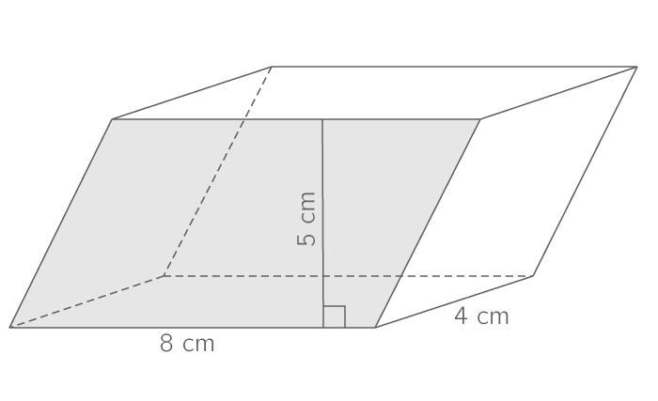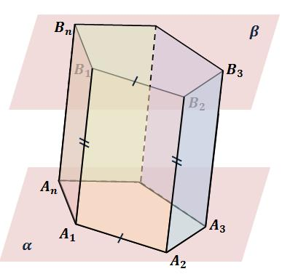

Constructing a Parallelogram-Based Prismoid

Geometric Instruments Used
# Source: AI Source: Provided by: [Data Path: Persons Table -> ID Column: 1, Name_En Column: Motasem Essam] -> From: [ChatGPT] on [7/25/2026]
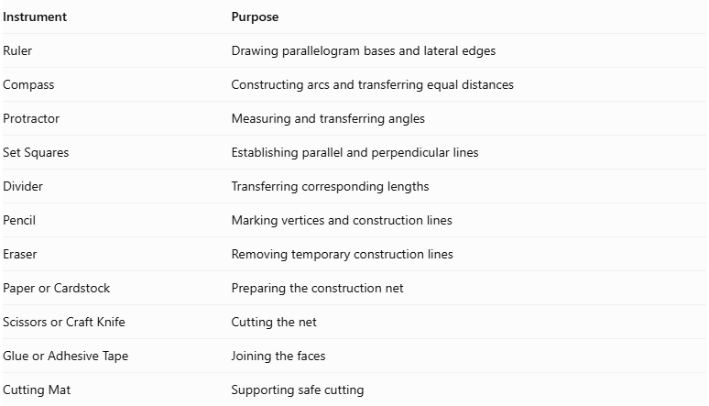
Instrument | Purpose
Ruler | Drawing parallelogram bases and lateral edges
Compass | Constructing arcs and transferring equal distances
Protractor | Measuring and transferring angles
Set Squares | Establishing parallel and perpendicular lines
Divider | Transferring corresponding lengths
Pencil | Marking vertices and construction lines
Eraser | Removing temporary construction lines
Paper or Cardstock | Preparing the construction net
Scissors or Craft Knife | Cutting the net
Glue or Adhesive Tape | Joining the faces
Cutting Mat | Supporting safe cutting

Instrument-Based Construction Procedures

Method 1: Construction Using a Geometric Net
# Source: AI Source: Provided by: [Data Path: Persons Table -> ID Column: 1, Name_En Column: Motasem Essam] -> From: [ChatGPT] on [7/25/2026]
- Determine the base dimensions: Choose the side lengths and interior angles of the upper and lower parallelogram bases.
- Construct the lower base: Use a ruler, compass, and protractor to draw the first parallelogram.
- Construct the upper base: Draw the second parallelogram with the required dimensions and vertex arrangement.
- Determine corresponding vertices: Match each vertex of the lower base with its corresponding vertex on the upper base.
- Determine the lateral edge lengths: Establish the lengths connecting the four pairs of corresponding vertices.
- Construct the lateral faces: Draw four planar quadrilaterals using the corresponding base edges and lateral edges.
- Arrange the net: Position the four lateral faces in sequence, with the upper and lower bases attached at their appropriate edges.
- Add joining tabs: Include tabs along selected external edges.
- Cut out the net: Carefully cut around its external boundary.
- Fold the faces: Fold along the designated joining edges.
- Join the structure: Attach the four lateral faces and both bases using glue or adhesive tape.
- Complete the solid: Check that all six faces meet correctly and that the model closes without gaps.

Method 2: Construction Using Two Parallel Parallelogram Bases
# Source: AI Source: Provided by: [Data Path: Persons Table -> ID Column: 1, Name_En Column: Motasem Essam] -> From: [ChatGPT] on [7/25/2026]
- Draw the lower base: Construct a parallelogram and label its vertices A, B, C, and D.
- Establish the height: Draw a perpendicular reference line representing the distance between the two base planes.
- Construct the upper base plane: Use set squares and a ruler to establish a plane parallel to the lower base plane.
- Draw the upper parallelogram: Construct the second parallelogram and label its vertices A′, B′, C′, and D′.
- Determine vertex correspondence: Match the vertices as follows:
- A with A′
- B with B′
- C with C′
- D with D′
- Draw the lateral edges: Connect the corresponding vertices:
- AA′
- BB′
- CC′
- DD′
- Construct the lateral faces: Connect the corresponding base edges to form four quadrilaterals:
- ABB′A′
- BCC′B′
- CDD′C′
- DAA′D′
- Check planarity: Verify that each lateral quadrilateral lies in a single plane.
- Complete the representation: Darken the visible edges and use dashed lines for hidden edges.
Important: The upper parallelogram cannot be positioned arbitrarily. Its vertices must be arranged so that all four lateral quadrilaterals are planar.

Method 3: Construction Through Parallel Cross-Sections
# Source: AI Source: Provided by: [Data Path: Persons Table -> ID Column: 1, Name_En Column: Motasem Essam] -> From: [ChatGPT] on [7/25/2026]
- Construct the lower base: Draw the first parallelogram.
- Construct the upper base: Draw the second parallelogram in a parallel plane.
- Connect corresponding vertices: Establish the four lateral edges.
- Construct the lateral faces: Form the four planar quadrilaterals.
- Locate the midpoint of each lateral edge: Use a divider to identify the halfway points on AA′, BB′, CC′, and DD′.
- Construct the midsection: Connect the four midpoint locations to form a quadrilateral parallel to both bases.
- Determine the cross-sectional areas: Calculate the lower-base, upper-base, and midsection areas.
- Complete the geometric representation: Label the three areas and the perpendicular height.
This method is useful for understanding and applying the prismoidal volume formula.

Related Geometric Solids
# Source: AI Source: Provided by: [Data Path: Persons Table -> ID Column: 1, Name_En Column: Motasem Essam] -> From: [ChatGPT] on [7/25/2026]
- Quadrilateral Prismoid: The broader family containing parallelogram-based prismoids.
- Parallelogram Prism: A special case with congruent parallel parallelogram bases.
- Parallelogram-Based Pyramidal Frustum: A related solid with similar parallelogram bases.
- Parallelogram-Based Pyramid: A solid with one parallelogram base and four triangular lateral faces.
- Parallelepiped: A related solid whose bases and lateral faces are parallelograms.

Main Classification
# Source: AI Source: Provided by: [Data Path: Persons Table -> ID Column: 1, Name_En Column: Motasem Essam] -> From: [ChatGPT] on [7/25/2026]
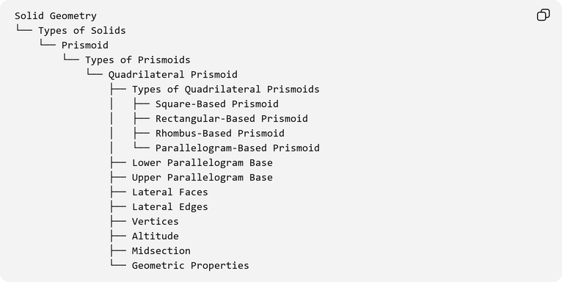
Solid Geometry
└── Types of Solids
└── Prismoid
└── Types of Prismoids
└── Quadrilateral Prismoid
├── Types of Quadrilateral Prismoids
│ ├── Square-Based Prismoid
│ ├── Rectangular-Based Prismoid
│ ├── Rhombus-Based Prismoid
│ └── Parallelogram-Based Prismoid
├── Lower Parallelogram Base
├── Upper Parallelogram Base
├── Lateral Faces
├── Lateral Edges
├── Vertices
├── Altitude
├── Midsection
└── Geometric Properties

Key Points
# Source: AI Source: Provided by: [Data Path: Persons Table -> ID Column: 1, Name_En Column: Motasem Essam] -> From: [ChatGPT] on [7/25/2026]
- A Parallelogram-Based Prismoid has two parallel parallelogram bases.
- Both bases have two pairs of parallel and equal opposite sides.
- It contains four quadrilateral lateral faces.
- It has 6 faces, 12 edges, and 8 vertices.
- Its bases may have different dimensions and angles.
- Its lateral faces are trapezoids or parallelograms.
- Its base angles are not necessarily right angles.
- Its volume is calculated using the prismoidal formula.

Conclusion
# Source: AI Source: Provided by: [Data Path: Persons Table -> ID Column: 1, Name_En Column: Motasem Essam] -> From: [ChatGPT] on [7/25/2026]
The Parallelogram-Based Prismoid is the parallelogram-base member of the Quadrilateral Prismoid family. Its two parallel parallelogram bases and four lateral faces define its geometric structure, allowing several configurations according to the dimensions, angles, and relative positions of its two bases.

